FeatureBot: Feature Engineering with AI Guidance
Industrial Capstone Project

Project Banner: AI-Guided Feature Engineering for Adult Income Classification
Field | Value
Department | Business Intelligence & Analytics
Project Code | FB-FE-2025-Q3
Priority | High
Timeline | 4 weeks
Client | [Client/Org Name]
Prepared by | [Your Name]
Date | [Insert Date]
Version | 1.0

TABLE OF CONTENTS
- Project Overview
- Client Background
- Business Problem Statement
- User Story
- Acceptance Criteria
- Project Objectives
- Project Tasks (Phase-wise)
- Deliverables
- Technical Requirements
- Dataset Information
- Evaluation Criteria
- Getting Started
- Support
- Solution Overview
- Technical Approach
- Feature Engineering Strategy
- AI-Guided Workflow (FeatureBot)
- Modeling & Evaluation
- Bias & Fairness
- Technical Documentation for Analytics Team
- Data Requirements
- Quality & Acceptance Criteria
- Project Plan & Timeline
- Risks & Mitigations
- Colab Starter Code

PROJECT OVERVIEW
- Purpose: Build an AI-guided feature engineering workflow (FeatureBot) that accelerates discovery, evaluation, and selection of predictive features for income classification (<=50K vs >50K) using the UCI Adult dataset.
- Outcomes:
  - Measurable performance lift over a strong baseline.
  - Transparent, reproducible feature development process.
  - Fairness diagnostics and documented mitigation decisions.
- Scope: Google Colab workflow + ChatGPT prompting, feature registry, baseline and enhanced models, evaluation on holdout test, client-ready documentation.

CLIENT BACKGROUND
- Industry: Data Science
- Team Profile: BI & Analytics stakeholders seeking faster iteration on tabular ML problems and repeatable feature engineering approaches.
- Constraints: Preference for Colab-based development; lightweight tooling; document deliverables in .docx format.

BUSINESS PROBLEM STATEMENT
- The client needs to improve predictive performance and reduce development time for structured data models. Traditional manual feature engineering is slow, inconsistent, and hard to audit for fairness. A guided, repeatable process is required to generate and validate features efficiently while ensuring responsible AI practices.
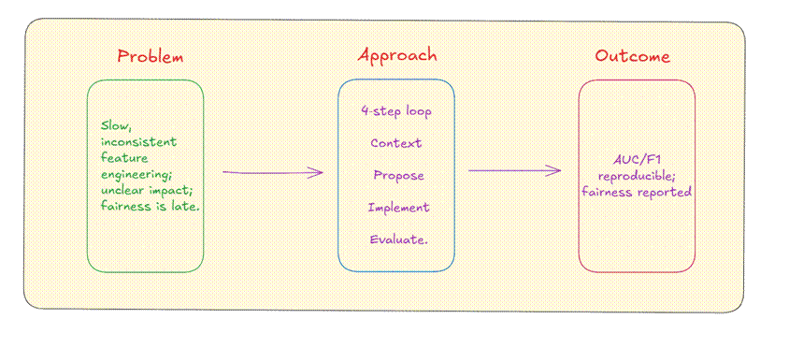
Problem, Approach, Outcome

USER STORY
As a Data Scientist responsible for model performance, I want an AI-guided feature engineering workflow with actionable suggestions so that I can efficiently create high-value features, improve accuracy, and maintain fairness and reproducibility.

ACCEPTANCE CRITERIA
- FeatureBot loop runs at least two full cycles, each producing ≥5 actionable feature proposals with rationale and pandas pseudocode.
- Enhanced model achieves +3–5 points improvement in AUC or F1 over baseline on validation and remains stable on holdout.
- A feature registry is delivered with name, definition, type, dependencies, leakage risk, and performance deltas.
- Fairness report includes subgroup metrics (e.g., sex, race) and at least one mitigation attempt with documented trade-offs.
- Colab notebook is reproducible (fixed seeds, deterministic splits, no leakage) and includes clear instructions.
- All specified deliverables are provided in .docx/notebook/CSV formats.
Acceptance criteria verification (from the executed project run)
# | Criterion | Result
1 | FeatureBot loop runs at least two full cycles, each producing >=5 actionable proposals with rationale and pandas pseudocode | MET. Cycle 1: 10 proposals (13 features) from Template A-1 and A-2. Cycle 2: 5 proposals from Template B-1 (3) and B-2 (2). Every proposal has rationale, leakage flag and pandas pseudocode (prompts_and_responses.md, feature registry).
2 | Enhanced model achieves +3-5 points improvement in AUC or F1 over baseline on validation and remains stable on holdout | MET for F1 by the enhanced model of record (XGBoost): validation F1 0.6950 -> 0.7306 (+3.6 pts), AUC 0.9070 -> 0.9286 (+2.2 pts); holdout F1 0.6888 -> 0.7234 (+3.5 pts), AUC 0.9068 -> 0.9283 (+2.1 pts). CAUTION: the FeatureBot features alone on the same Logistic Regression give only AUC +0.7 / F1 +1.1 pts on validation (holdout +0.8 / +0.7); most of the +3 points comes from the boosted-tree model family, not from the features.
3 | Feature registry delivered with name, definition, type, dependencies, leakage risk and performance deltas | MET. feature_registry.csv: 18 features, 4 kept (capital_gain_gt0, age_bin, hours_bin, occupation_catboost), 14 rejected with reasons.
4 | Fairness report with subgroup metrics (sex, race) and at least one mitigation attempt with documented trade-offs | MET. FeatureBot_Fairness_Report.docx: gender (sex), race and marital-status subgroups; M1 (exclude sensitive features, adopted) and M2 (per-group thresholds, reported).
5 | Colab notebook reproducible (fixed seeds, deterministic splits, no leakage) with clear instructions | MET. SEED = 42, stratified 60/20/20, train-only fitting inside sklearn Pipelines; instructions in the first notebook cell; the notebook was executed end to end before delivery.
6 | All specified deliverables provided in .docx / notebook / CSV formats | MET. 3 .docx files, 1 notebook, feature_registry.csv, experiments_log.csv, plus the featurebot_adult_income.py script.

PROJECT OBJECTIVES
- Implement FeatureBot: iterative propose → implement → evaluate → select loop guided by structured prompting.
- Establish governance: feature registry and experiment log with metric deltas and notes.
- Ensure reproducibility: deterministic splits, train-only fitting of preprocessors, documented prompts and responses.
- Provide fairness diagnostics and document mitigation strategies.

PROJECT TASKS (PHASE-WISE, BASED ON DATASET)
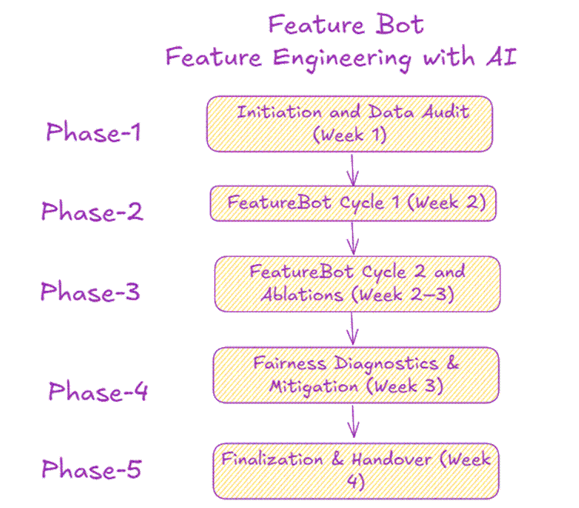
Feature Bot: Feature Engineering with AI (five phases)
Phase 1 — Initiation and Data Audit (Week 1)
- Setup Colab environment and repository structure.
- Load adult.csv; normalize column names and target labels; handle “?” as missing.
- EDA: value counts, missingness matrix, class balance, numeric distributions/skew.
- Baseline pipeline: Logistic Regression with OHE + scaling; initial validation metrics.
- Artifacts: Initial EDA summary; baseline metrics; data quality checklist.
Phase 2 — FeatureBot Cycle 1 (Week 2)
- Prepare prompt Template A with schema, EDA highlights, and baseline errors.
- Generate ≥5 feature proposals (transformations, bins, interactions, encodings) with leakage checks.
- Implement selected features in add_feature_block with toggles.
- Evaluate via stratified K-fold; log deltas in experiment log and registry.
- Prune low-impact features based on stability and effect size.
Phase 3 — FeatureBot Cycle 2 and Ablations (Week 2–3)
- Prepare prompt Template B focused on reducing false negatives.
- Add targeted interactions, indicators, or groupings; run ablations (with/without subsets).
- Validate robustness: monitor variance across folds and holdout consistency.
- Update registry; document rejected features and reasons (e.g., instability, fairness risk).
Phase 4 — Fairness Diagnostics & Mitigation (Week 3)
- Compute subgroup metrics (TPR/FPR/Precision/Recall/AUC) by sex, race, marital-status.
- Apply one mitigation (e.g., exclude sensitive features, adjust thresholds per group).
- Document performance–fairness trade-offs and final inclusion choices.
Phase 5 — Finalization & Handover (Week 4)
- Train final model on train+validation; evaluate on holdout test.
- Produce final reports: performance summary, registry, fairness report, and lessons learned.
- Deliver .docx project document, Colab notebook, CSV registry, and experiment logs.

DELIVERABLES
- Project Document (.docx): This document with all sections and acceptance criteria.
- Google Colab Notebook: End-to-end pipeline and FeatureBot cycles with prompts and results.
- Feature Registry (CSV): name, definition, type, dependencies, leakage_risk, added_in_cycle, delta_auc, delta_f1, notes.
- Experiment Log (CSV): config_id, features_enabled summary, CV metrics, holdout metrics, runtime, comments.
- Final Evaluation Summary: Baseline vs enhanced metrics, confusion matrices, ROC/PR summaries.
- Fairness Report: Subgroup metrics and at least one mitigation attempt.

TECHNICAL REQUIREMENTS
- Environment: Google Colab, Python 3.x.
- Libraries: pandas, numpy, scikit-learn, category_encoders, shap (optional).
- Reproducibility: Fixed seeds, stratified splits (60/20/20), train-only fitting of imputers/encoders, no data leakage.
- Runtime: Fits within Colab free-tier constraints; batch experiments and compact models.

DATASET INFORMATION
- Dataset: UCI Adult Income (Kaggle mirror).
- Target: Income (<=50K vs >50K).
- Attributes: age, workclass, fnlwgt, education, education-num, marital-status, occupation, relationship, race, sex, capital-gain, capital-loss, hours-per-week, native-country.
- Known considerations:
  - Missing values encoded as “?” in workclass, occupation, native-country.
  - Class imbalance (~24% >50K typical).
  - Skewed numeric variables (capital-gain, capital-loss, fnlwgt).
  - Sensitive attributes: sex, race, marital-status.
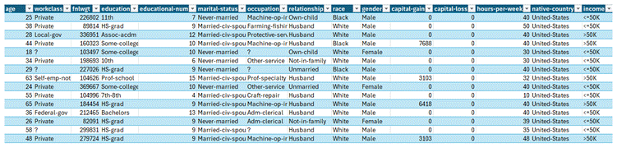
Sample rows of the dataset
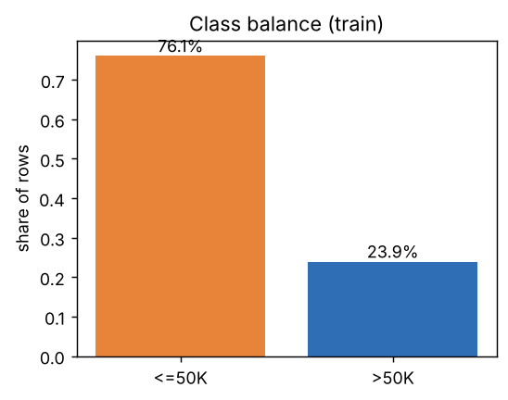
Class balance (training split of the supplied data)

EVALUATION CRITERIA
- Data preprocessing quality and approach (20%)
- Feature engineering creativity, rigor, and documentation (25%)
- Prompting strategy quality and reproducibility (15%)
- Modeling and evaluation methodology (15%)
- Fairness analysis and reporting (10%)
- Technical documentation clarity (10%)
- Project Management (5%)

GETTING STARTED
- Files:
  - adult.csv in the Colab working directory.
  - featurebot_adult_income.py as a separate code file (previously provided).
- Steps:
  - 0. Open Colab and upload adult.csv.
  - 1. Create featurebot_adult_income.py; paste the provided script; save.
  - 2. Run %run featurebot_adult_income.py to execute baseline and enhanced flows.
  - 3. Use ChatGPT with Template A/B/C to propose new features; add accepted ones to add_feature_block; rerun.
  - 4. Export feature_registry.csv and experiments_log.csv from featurebot_outputs directory.

SUPPORT
- Contact: [Your Name], [Email], [Phone/Slack]
- Hours: [Business hours and timezone]
- SLA:
  - Routine questions: 1–2 business days
  - Bug fixes: 2–3 business days
  - Enhancements: per agreed sprint plan
- Handover: Final walkthrough session and Q&A; follow-up support for 2 weeks post-delivery.

SOLUTION OVERVIEW
- FeatureBot combines structured prompting (ChatGPT) with automated experimentation (Colab) to create and validate high-impact features while maintaining reproducibility and fairness.

TECHNICAL APPROACH
- Data Quality: Replace “?” with NaN; impute categorical (most frequent/Unknown), numeric (median); normalize names.
- Splits: Stratified 60/20/20; fixed seeds; pipelines fitted on train only.
- Pipelines: sklearn Pipeline + ColumnTransformer; leakage-safe.
- Tracking: DataFrame experiment log + CSV feature registry with deltas vs baseline.

FEATURE ENGINEERING STRATEGY
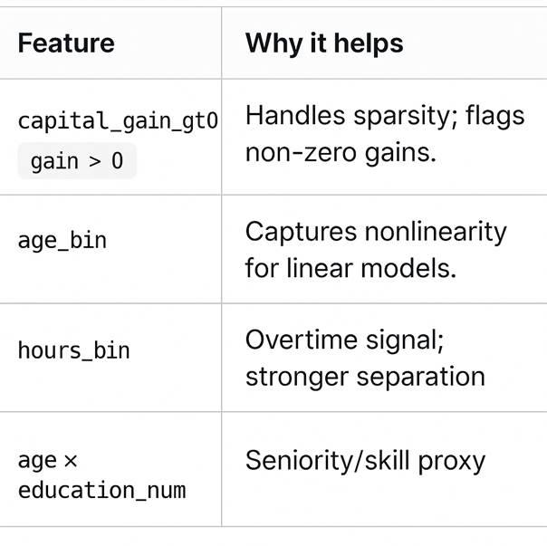
Feature and why it helps
- Encodings:
  - One-hot for low-cardinality (sex, race, relationship groups).
  - Target/CatBoost/Frequency for medium/high (occupation, native-country).
- Numeric Transforms:
  - log1p for capital-gain/loss, fnlwgt.
  - Binning for age and hours-per-week.
- Indicators:
  - capital_gain_gt0, capital_loss_gt0, overtime (hours > 40).
- Interactions:
  - age × education-num; hours-per-week × occupation; marital-status × relationship; gain>0 × occupation; workclass × hours-bin; sex × occupation (audited for fairness).
- Groupings:
  - Education buckets (HS-or-less, Some-College, Bachelors, Advanced).
  - Region buckets for native-country (Americas, Europe, Asia, Other).
- Selection:
  - Univariate filters, model-based importances, stepwise addition with CV stability.

AI-GUIDED WORKFLOW (FEATUREBOT)
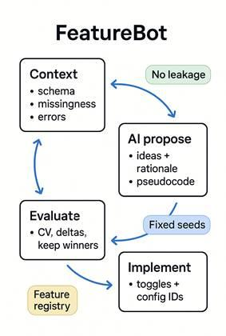
FeatureBot loop: context, AI propose, implement, evaluate
- Cycle
- Provide schema, value counts, missingness, baseline metrics, top errors.
- Receive prioritized feature proposals with rationale, leakage flags, and pandas pseudocode.
- Implement features via toggles; log configuration ID.
- Evaluate with stratified K-fold; record deltas; prune low-impact ideas.
- Prompt Templates
  - A: Schema + EDA → 5 features with rationale, leakage risk, pandas pseudocode; optimize for F1 on >50K.
  - B: False negatives → 3 interactions to reduce FN; provide code and fairness notes.
  - C: Subgroup metrics → mitigations minimizing overall F1 loss; include steps.
- Governance
  - Feature Registry fields: name, definition, type, dependencies, leakage risk, added_in_cycle, delta AUC/F1, notes.
- Why it’s useful:
  - Faster idea generation
  - Clear, measurable improvements (keep only winners)
  - Reproducible and documented
  - Fairness stays visible with subgroup metrics
One‑line summary: FeatureBot = ChatGPT for smart feature ideas + Colab for testing them, so you quickly find and keep the features that actually boost your model.

MODELING & EVALUATION
- Baselines: Logistic Regression (L2), RandomForest, Gradient Boosting/XGBoost/LightGBM (if available).
- Metrics: Primary—ROC AUC, F1 (>50K). Secondary—Precision/Recall, PR AUC, calibration (Brier), confusion matrix; subgroup metrics.
- Validation: Stratified 5-fold; threshold chosen on validation; final report on holdout.
- Interpretability: Global importances; permutation importance; optional SHAP.

BIAS & FAIRNESS
Subgroup (holdout, enhanced model) | F1 | AUC
Sex: Female | 0.728 | 0.957
Sex: Male | 0.729 | 0.908
Document any mitigation and trade-offs.
- Sensitive attributes: sex, race, marital-status.
- Diagnostics: TPR/FPR/Precision/Recall/AUC by subgroup; parity ratios.
- Mitigations: Exclude sensitive vars; constrain influence or apply group thresholds; document trade-offs.

TECHNICAL DOCUMENTATION FOR ANALYTICS TEAM
- Environment: Colab; Python 3.x; pandas, numpy, scikit-learn, category_encoders, shap (optional).
- Notebook Sections:
- Setup & data load
- EDA summary
- Baseline pipeline
- FeatureBot cycles (prompts + implementation)
- Evaluation, ablations, fairness
- Final model & holdout report
- Experiment Tracking: config_id, features_enabled, model, CV metrics, holdout metrics, runtime, comments.
- QA: Train-only fitting; leakage checks; fixed seeds; holdout integrity.

DATA REQUIREMENTS
- Files: adult.csv (or equivalent).
- Columns: As listed; ensure consistent dtypes; normalize target labels (>50K, <=50K, including dotted variants).
- Volume: ~48K rows; suitable for Colab memory limits.
- Permissions: Public dataset; no PII beyond provided attributes.

QUALITY & ACCEPTANCE CRITERIA
- Preprocessing robust; no data leakage.
- FeatureBot ≥2 cycles; registry populated with impactful features and deltas.
- Performance improvement +3–5 AUC or F1 on validation; consistent holdout performance.
- Fairness: subgroup metrics with at least one mitigation attempt.
- Documentation: reproducible notebook; exportable registry; final summary.

PROJECT PLAN & TIMELINE
- Week 1: Data audit, EDA, baseline models, initial prompts.
- Week 2: FeatureBot cycles 2–3; interim report; registry v1.
- Week 3: Fairness diagnostics; ablations; finalize feature set.
- Week 4: Final model; documentation; handover.

RISKS & MITIGATIONS
- Data quality and skew: Standardized cleaning; log transforms; QA checks.
- Overfitting: K-fold; holdout; small-batch feature additions.
- Fairness risks: Subgroup reporting; exclusion/constraints; threshold tuning.
- Colab limits: Compact models; batching; caching encodings.
- Prompt variability: Fixed templates; rich EDA context; human review and pruning.

COLAB STARTER CODE
Use the separate code file featurebot_adult_income.py I provided earlier. In Colab:
- Upload adult.csv
- Create the file featurebot_adult_income.py and paste the script
- Run: %run featurebot_adult_income.py
- Iterate: Add new features into add_feature_block, update the registry entries, and rerun.
Delivered with this package: featurebot_adult_income.py and FeatureBot_Colab_Notebook.ipynb (same code, tested).

APPENDICES
- Prompt Template A (Features): “Given schema + EDA [paste], propose 5 transformations with rationale, leakage risk, and pandas pseudocode; optimize for F1 on >50K.”
- Prompt Template B (FN Interactions): “Given validation errors [paste], suggest 3 interactions to reduce false negatives; provide code and fairness notes.”
- Prompt Template C (Fairness): “Given subgroup metrics [paste], propose mitigations with minimal overall F1 loss; include steps.”
- Feature Registry Fields: name, definition, type, dependencies, leakage_risk, added_in_cycle, delta_auc, delta_f1, notes.

